If you’re looking for a breeze this summer, be sure to stop by the Four Seasons Hotel in downtown Houston on Friday nights. All summer long they are hosting a free poolside music series that is open to the public, and includes complimentary valet. Come enjoy food and drink specials and games on the poolside deck 7-10 PM. Don’t miss this great opportunity to relax and have a good time while enjoying some of your favorite local performers!

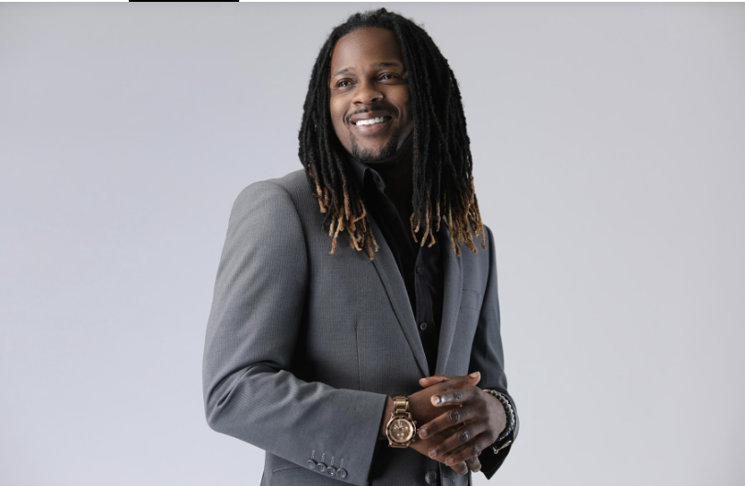

May 24th, 7:00-10:00 PM
DJ SoulStar
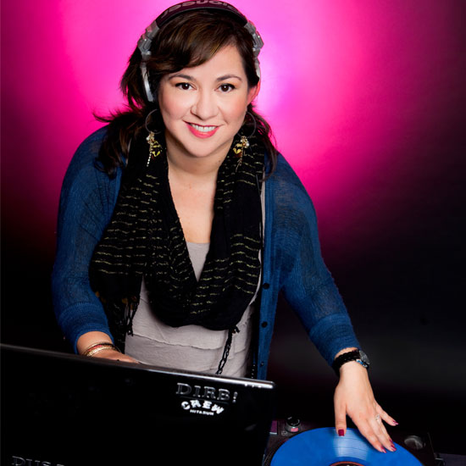

May 3st, 7:00-10:00 PM
DJ Gracie Chavez

June 7th, 7:00-10:00 PM
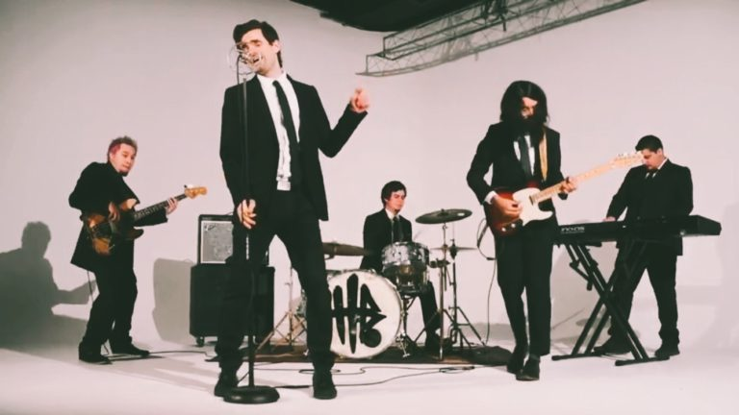
Nick and the Hits (Band)

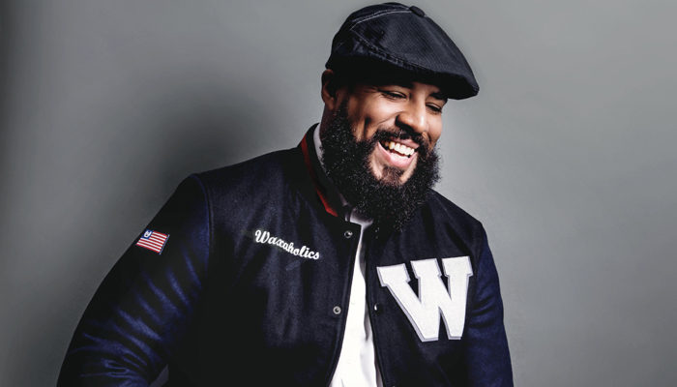

June 14th and June 28, 7:00-10:00 PM
DJ Big Reeks

July 5th, 7:00-10:00 PM
DJ SoulStar

July 12th, 7:00-10:00 PM
IDT (Band)

July 19th, 7:00-10:00 PM
DJ SoulStar

July 26th and August 2nd, 7:00-10:00 PM
DJ Big Reeks

August 9th, 7:00-10:00 PM
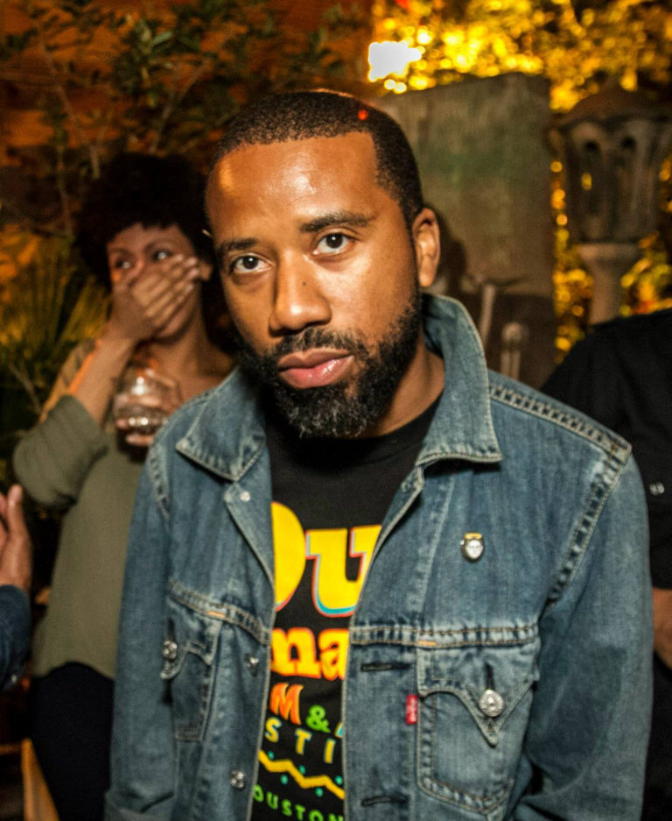
DJ Flash Gordon Parks

August 16th, 7:00-10:00 PM
Adrian Michael Trio (Band)

August 23rd and 30th, 7:00-10:00 PM
DJ Flash Gordon Parks

